Asimov, Futuredays – Vision of the Year 2000, Henry Holt, 1986 First American Version Fist print, Hong Kong. No DJ. As new soft cover, spine is straight with all 96 pages tightly bound and no marks of any kind. measuring approximately 8.25" x 9.25" ISBN: 0805001204
“In 1899, Jean Mare Cote, a French commercial artist, was commissioned to produce illustrations for a series of cigarette cards to coincide with the celebration being held throughout France to mark the turn of the century. …Fifty of these cards are reproduced in full colour here, with lively commentary and analysis.” From back of book cover.
"The desire to know our individual destinies has been linked, through the centuries, with our desire to foretell what will happen to humanity as a whole, to comprehend in all its complexity the grand sweep of history." In "Futuredays," the artist's imagination tackles the uncertainties of the future with delightful, amusing, and surprisingly accurate results.".
ID 000388 Price $250 Box 9
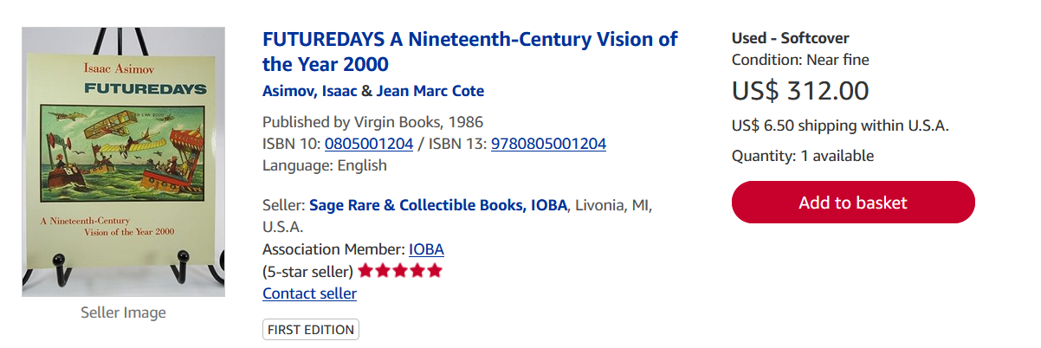
Copies listed on sites like AbeBooks and Amazon range from $300 to $900, indicating collector interest and limited availability. A modest run

